New Research Is a Case of the Gut Leading the Blind

Aug 19, 2015

The microbiota of the human gut has become increasingly important toward the study of various disease states and has been implicated to play a pivotal role in immune response pathways. One area that has been seemingly disconnected from activities in the gut is vision—a new study, however, from researchers at the National Institutes of Health (NIH) may open the eyes of many scientists studying autoimmune uveitis.
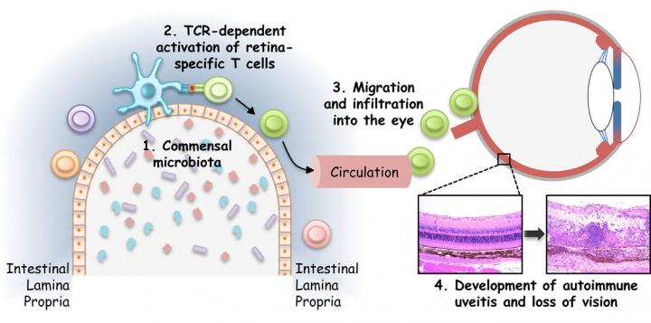
Autoimmune uveitis is a major cause of blindness in the western world, accounting for up to 15% of cases. The disease is triggered by the activation of T cells, but until recently, investigators remained perplexed as to exactly how and where the T cells get switched on. The NIH scientists observed that gut microbes produced a molecule that closely mimics a retinal protein—an event that is strongly associated with the T cell activation for this disease.
The larger implication of this study is not only the gut microbiome’s contribution to autoimmune disorders, but also that a greater understanding of the underlying molecular mechanisms could pave the way toward the development of novel therapeutic prevention strategies.
"Given the huge variety of commensal bacteria, if they can mimic a retinal protein, it is conceivable that they could also mimic other self-proteins that are targets of inappropriate immune responses elsewhere in the body," explained senior study author Rachel Caspi, Ph.D., senior investigator at the NIH. "We believe that activation of immune cells by commensal bacteria may be a more common trigger of autoimmune diseases than is currently appreciated."
The findings from this study were published recently in Immunity through an article entitled “Microbiota-Dependent Activation of an Autoreactive T Cell Receptor Provokes Autoimmunity in an Immunologically Privileged Site.”
Since the blood-retinal barrier sequesters retinal proteins within the eye, scientists had always run into a paradox when studying autoimmune uveitis: how did the proteins make it out of the eye to activate T cells, which cannot enter the eye unless activated. Clues began to emerge over the past several years, as evidence for an association between the gut microbiome and other autoimmune disorders grew. Moreover, some anecdotal reports suggested that uveitis was reactivated following bacterial infections. This led the NIH team to take a look at gut proteins for potential culprits.
“In the present study we used the R161H mouse model of uveitis to study natural triggers of the disease,” the scientists wrote “Our data indicate that a microbiota-dependent signal activates retina-specific T cells in the gut lamina propria that precedes clinical onset of the disease in the eyes. More importantly, activation of these T cells is independent of the endogenous antigen and involves signaling through the clonotypic autoreactive TCR by microbiota-dependent stimuli.”
Dr. Caspi and her team were able to show that bacteria-rich protein extracts from the gut contents of these mice activated retina-specific T cells, making them capable of breaching the blood-retinal barrier to enter the eye and cause uveitis.
“Our study uncovers a novel mechanism whereby engagement of the specific T cell receptor by non-cognate stimuli in the gut activates autoreactive T cells and contributes to autoimmune disease,” the scientists reported.
Dr. Caspi and her team were excited by their findings and are now trying to identify specific bacteria that could produce the protein mimicking the retinal antigen in their animal model of uveitis. They will also look for additional signals that could contribute to the activation of disease-causing immune cells.
"Bioinformatic analyses combined with biological tests will help us to reach this goal, but there is still much work to be done," Dr. Caspi noted. “We may be able in the future to use this knowledge to selectively eliminate the responses that lead to the development of this disease."

